**CRUD OPERATIONS FOR CRM**

1. DISPLAYING ALL RECORDS

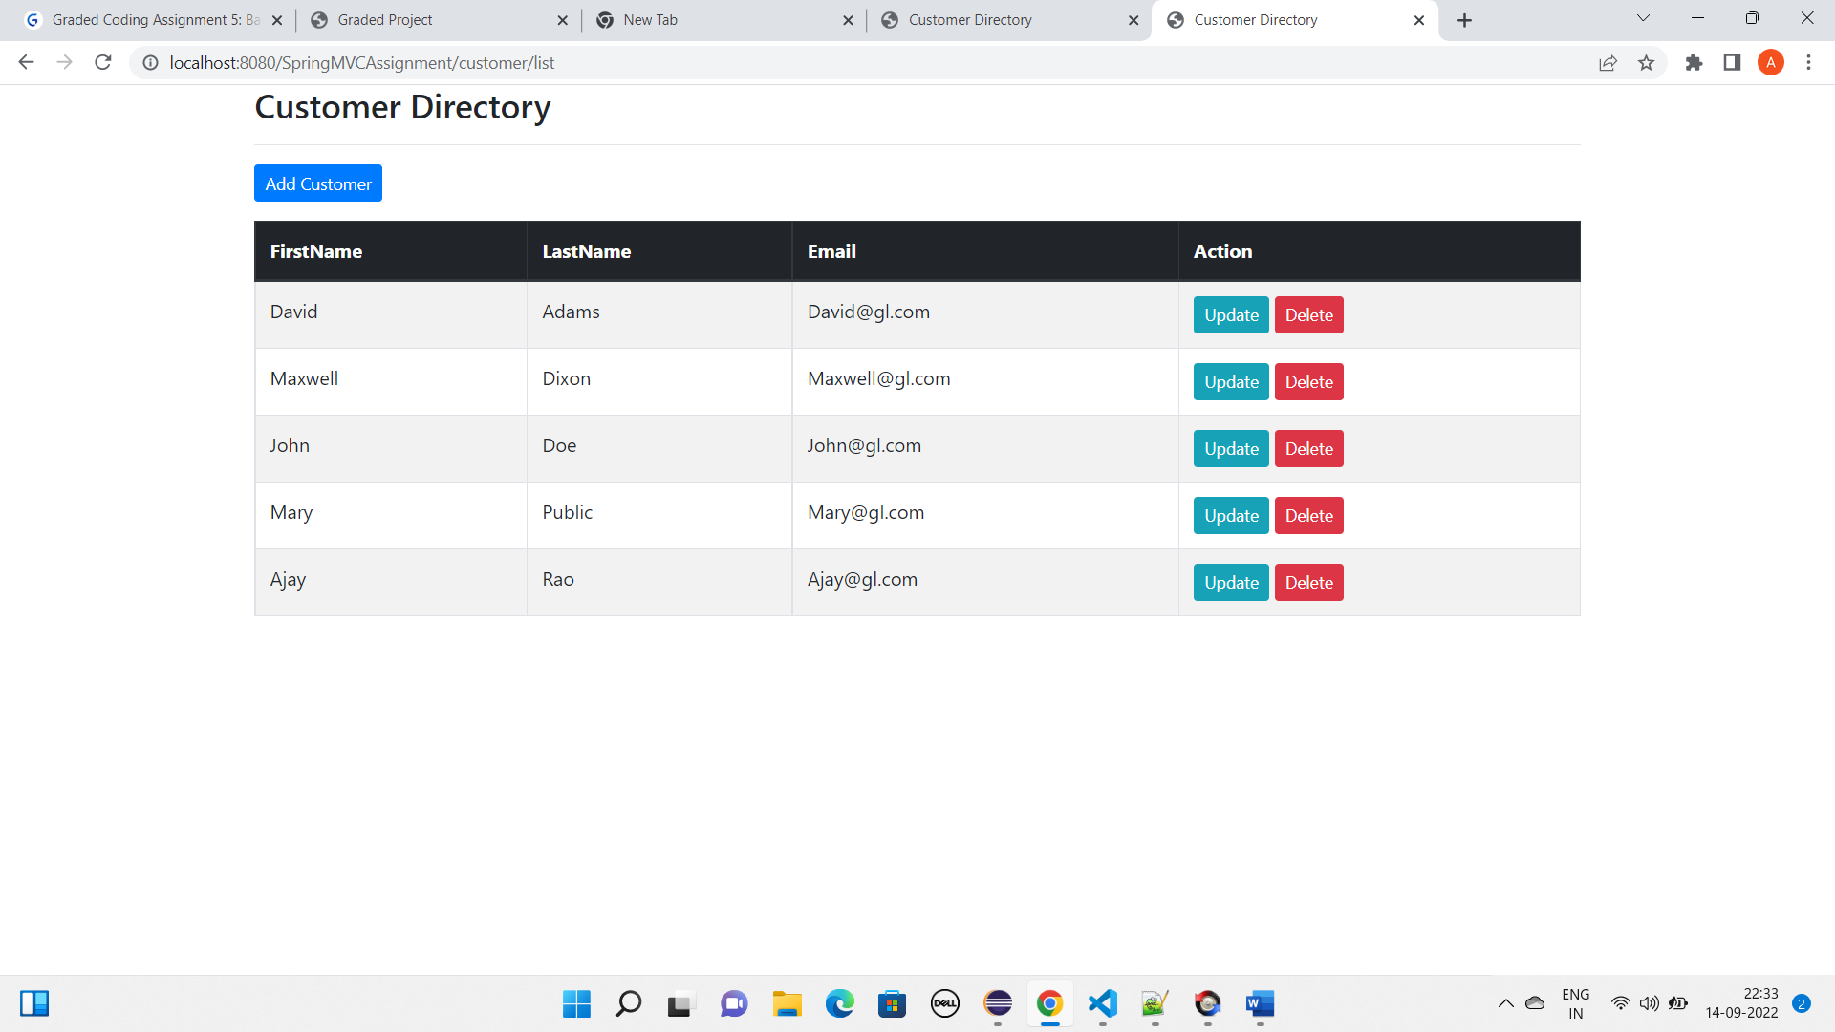

1. INSERTING A NEW CUSTOMER RECORD

* Add a new record through the form

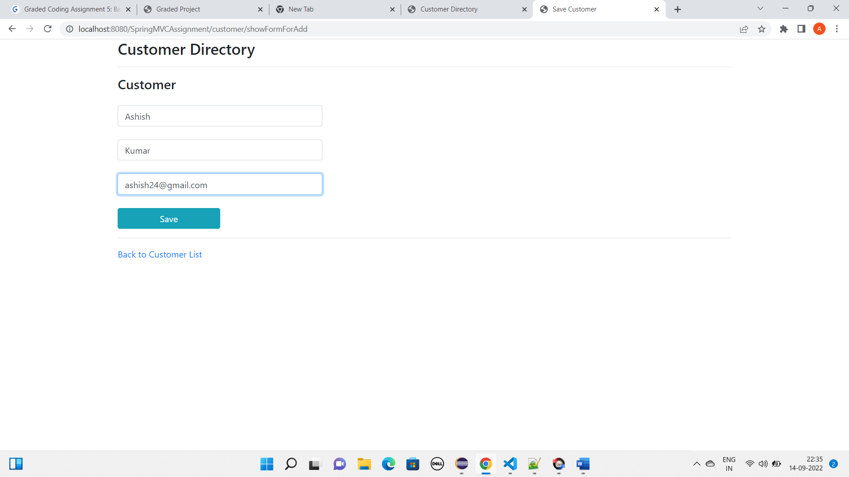

* Displaying the new record along with existing records

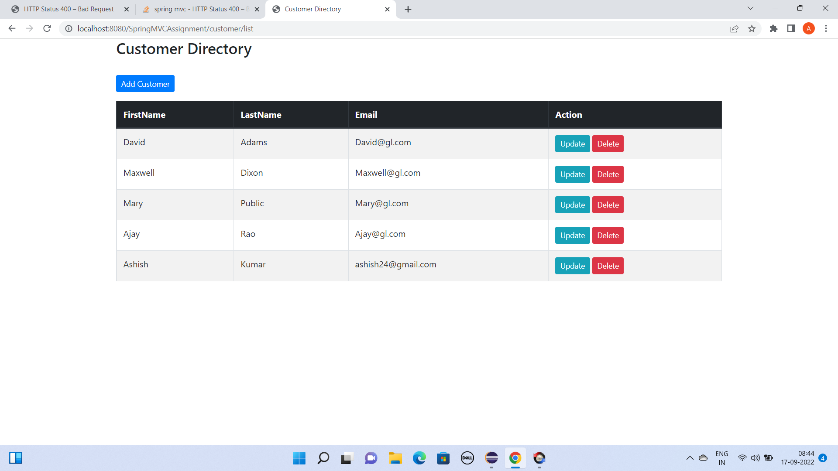



1. UPDATING A CUSTOMER RECORD

* Updating the email id of the 2nd record(Maxwell’s)

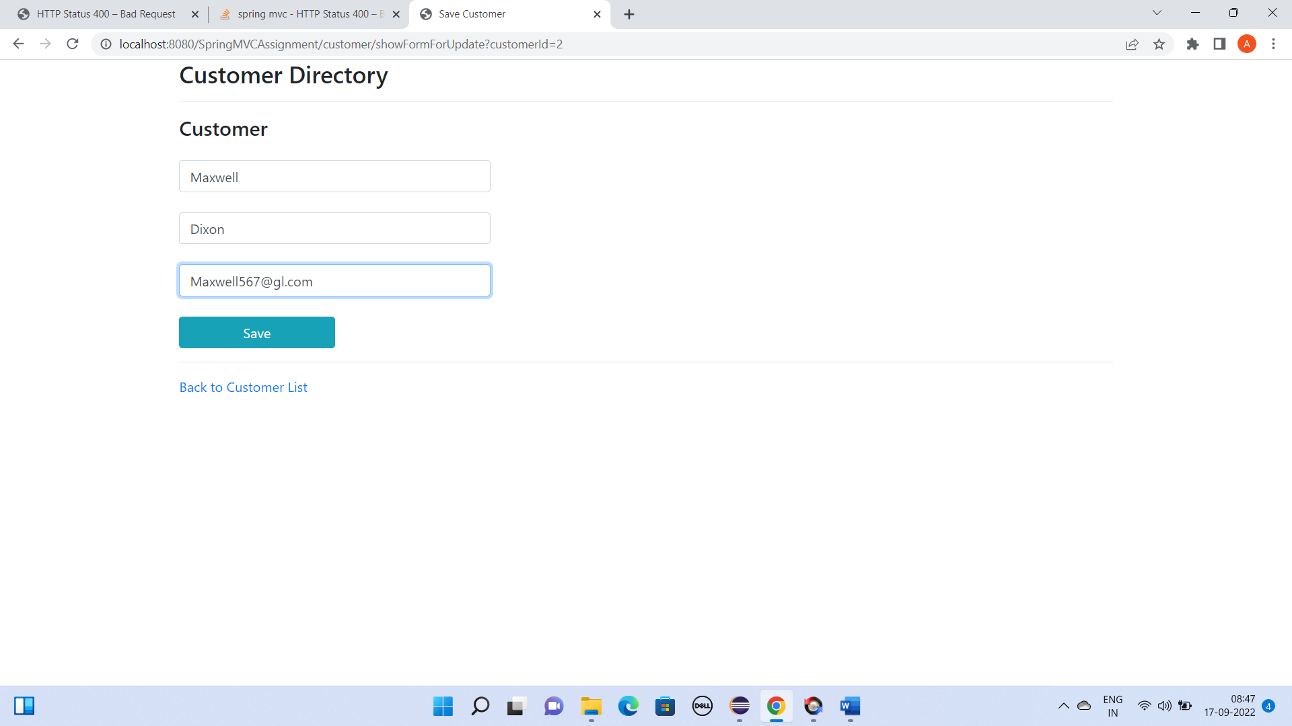



* Displaying the updated record

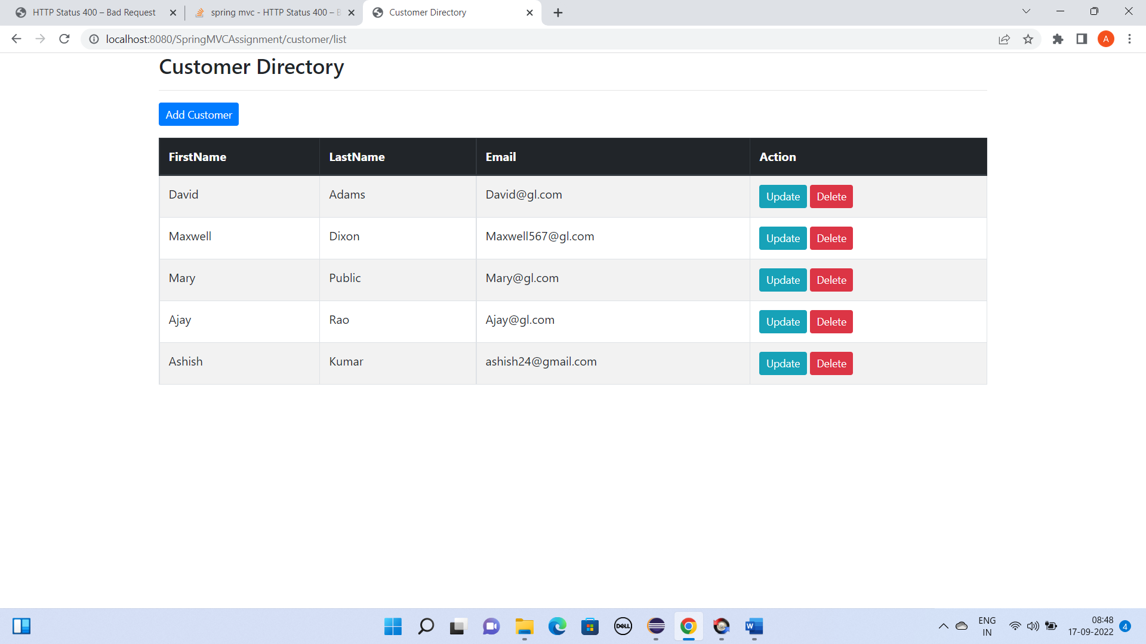



1. DELETING A CUSTOMER RECORD

* While deleting John’s record

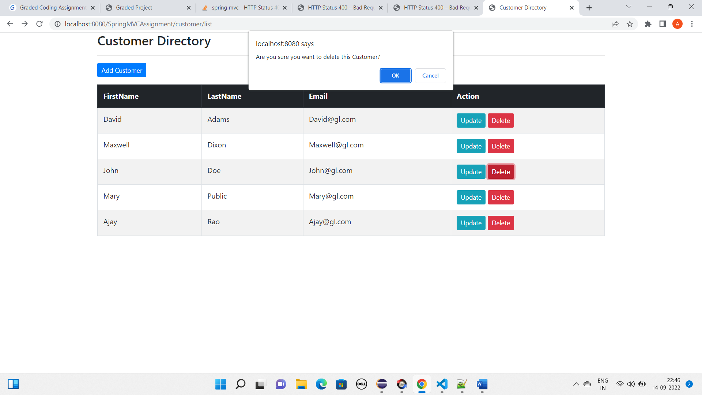



* After deleting the 3rd (John’s) record

